Grocery Stores in the Bronx

Jeremy Cox

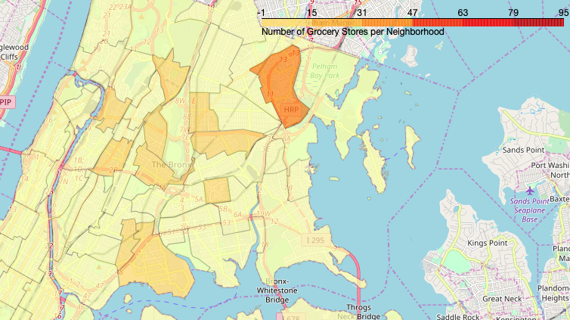

# Introduction and Background

New York City is one of the most densely populated cities in the United States, and its population only continues to grow. With this growth comes many challenges, especially when it comes to food security. Areas that lack reliable access to food are known as food deserts, or alternatively "low-access communities." The United States Department of Agriculture (USDA) provides the following guidance on what is considered a low-access community:

"To qualify as a low-access community, at least 500 people and/or at least 33 percent of the census tract's population must reside more than one mile from a supermarket or large grocery store (for rural census tracts, the distance is more than 10 miles)"[USDA].

This report will focus on identifying neighborhoods with poor access to grocery stores, as well as ranking neighborhoods in New York City in terms of access to grocery stores.

The findings of this report will be of particular interest to smaller grocery stores, particularly ones looking to service areas that don't meet the requirements for larger supermarkets (like Whole Foods, Safeway, or Kroger). Identifying underserved neighborhoods can be a great opportunity for small-to-medium size grocery stores to create and maintain loyal customers while improving the health and well-being of the neighborhood they are serving.

## Data Description

In order to locate, identify, and plot grocery stores in the Bronx, the Foursquare API will be utilized. (<https://foursquare.com/>)

It will also be necessary to identify neighborhood names, boundaries, and populations. To find this data, NYC Open Data will be referenced. ([https://data.cityofnewyork.us](https://data.cityofnewyork.us/))

1. Methodology, Results, and Discussions
2. In order to map grocery stores by neighborhood, a data frame must be made containing neighborhood coordinates as well as neighborhood and borough names. The data was collected from NYC Open Data, from which the necessary details were gathered. Because this project focus on the Bronx, the data frame was further cleaned, removing all neighborhoods not in the Bronx. The first five rows can be seen below:

**Figure One: Neighborhood Data**  
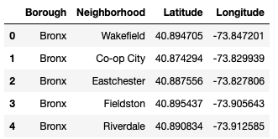

1. Next, it was time to use the above data to find grocery stores near the coordinates of each Bronx neighborhood using the Foursquare API. A function was created to identify all grocery stores within 30 kilometers of a neighborhood’s central point (designated by the latitude and longitude columns in “Neighborhood Data”). This function was applied to all neighborhoods in the Bronx. The results were entered into a new data frame titled “Bronx Groceries.” Because the search radius allowed for overlap of neighborhoods, some grocery stores were duplicated in the “Bronx Groceries” data frame. Using Foursquare’s unique ‘VenueID,’ duplicate entries were removed, bringing the total number of venues from 4,930 to 416. The first five rows of “Bronx Groceries” can be seen below:

**Figure Two: Bronx Groceries**

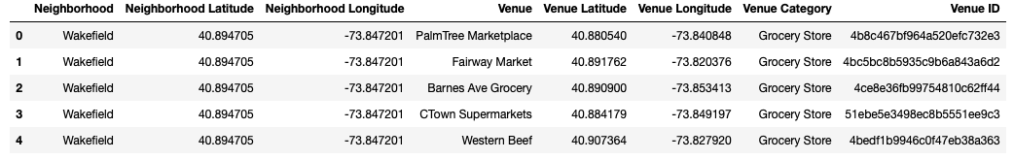

1. With a comprehensive list of grocery stores and their respective neighborhoods, it was possible to create a table containing total number of grocery stores per neighborhood. This new data frame was titled “Grocery Stores per Neighborhood.” The first five rows can be seen below:

**Figure Three: Grocery Stores per Neighborhood**

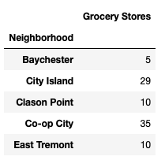

1. With all of the relevant details gathered for each grocery store and neighborhood, it was then possible to create maps to visualize grocery store distribution. The first map created was a heat map, denoting clusters of grocery stores throughout the Bronx (Figure Four).

Figure Four: Grocery Store Heat Map

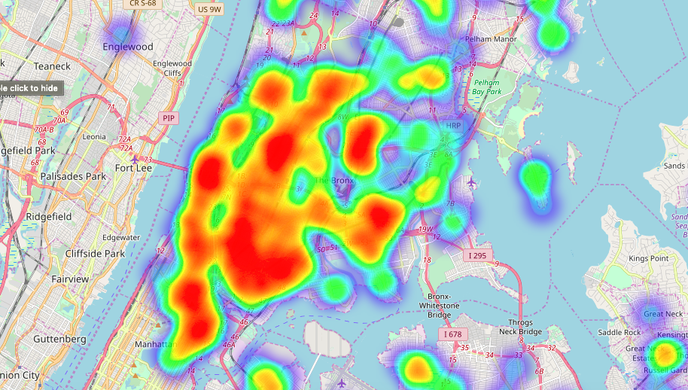

While the heat map is interesting, it does have limitations. In order to visualize grocery stores per neighborhood and compare neighborhoods with each other, it was more useful to create a choropleth. Utilizing the grocery store data from Foursquare and neighborhood boundaries from NYC Open Data, the following choropleth was created:

Figure Five: Grocery Store Choropleth



As evidenced by the Figure Five, grocery stores in the Bronx tend to be fairly clustered in specific neighborhoods, with many neighborhoods having no grocery stores at all. This uneven distribution could also be seen by analyzing the “Grocery Stores per Neighborhood” data frame. A basic analysis yielded the following results:

Figure Six: Grocery Stores per Neighborhood Analysis

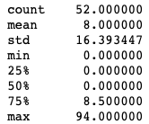

Figure Six demonstrated that over 75% of Bronx Neighborhoods had fewer than 10 grocery stores and over half had no grocery stores at all.

1. The uneven distribution of grocery stores in the Bronx raised an important question: Do neighborhoods with higher populations have more grocery stores? To answer this question, it was first necessary to download the population data from NYC Open Data and format it in a data frame titled “Bronx Population Data.” The first five rows can be seen below (Note: NTA stands for “Neighborhood Tabulation Area,” or neighborhood):

Figure Seven: Bronx Population Data

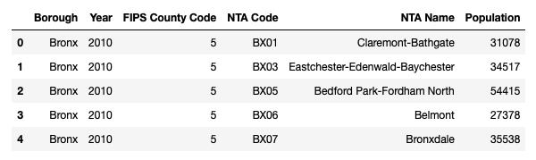

Using the above data frame, it was possible to create a choropleth comparing population of neighborhoods in the Bronx (Figure Eight).

Figure Eight: Bronx Population by Neighborhood

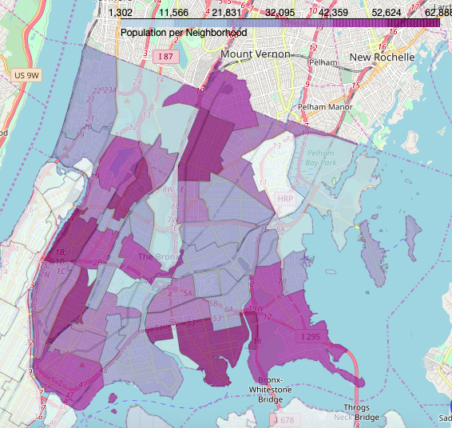

After comparing Figures Five and Eight, two things became apparent:

1. Population distribution was not nearly as skewed as grocery store distribution.
2. Neighborhoods with high populations did not always more grocery stores.
3. To confirm the two findings from section E, it was necessary to look at the data. For the first finding, the population data from “Bronx Population Data” was analyzed, resulting in the following:

Figure Nine: Population Distribution Analysis

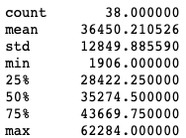

The data in Figure Nine confirmed that population per neighborhood was distributed more evenly than grocery stores per neighborhood.

To confirm the second finding, it was useful to rank each neighborhood by number of grocery stores and by total population. Unfortunately, the data was not able to be combined, due the population data lumping some neighborhoods together. This did not significantly alter findings, due largely to the skewed nature grocery store distribution.

Figure 10: Top Five Neighborhoods for Grocery Stores

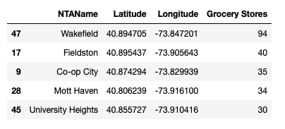

Figure 11: Top Five Neighborhoods for Population

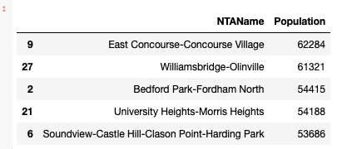

From the above figures, it could be seen that of the top five neighborhood clusters in terms of population, only one neighborhood (University Heights) could be seen on the list of top five grocers.

1. Conclusion

After mapping grocery stores in neighborhoods in the Bronx and comparing their distribution to neighborhood populations, it was determined that access to grocery stores in the Bronx is not equal for all Bronx residents. Some neighborhoods, such as Wakefield, enjoyed a high density of grocery stores while over half of the neighborhoods had none. Likewise, the East Concourse-Concourse Village area had the highest population in the Bronx but was home to zero grocery stores.

The large number of neighborhoods lacking grocery stores could be explained by a number of factors, including limited floor space of venues due to density and high rent costs per square foot. Those challenges are particularly daunting for large stores such as Kroger and Walmart while leaving smaller grocery chains less affected. Though grocery store substitutes like bodegas and farmers markets are plentiful in New York, their limited offerings restrictive schedules make them less able to combat food insecurity than grocery stores.

If a potential owner of a small grocery store wishes to open a business in the Bronx, the above data points toward neighborhoods such as East Concourse and Concourse Village in order to reach many customers with little competition. Likewise, he or she should avoid neighborhoods such as Wakefield or Fieldston, where competition is most intense.